Paul Kafka
4/12/12
FPLD’s
Homework 8
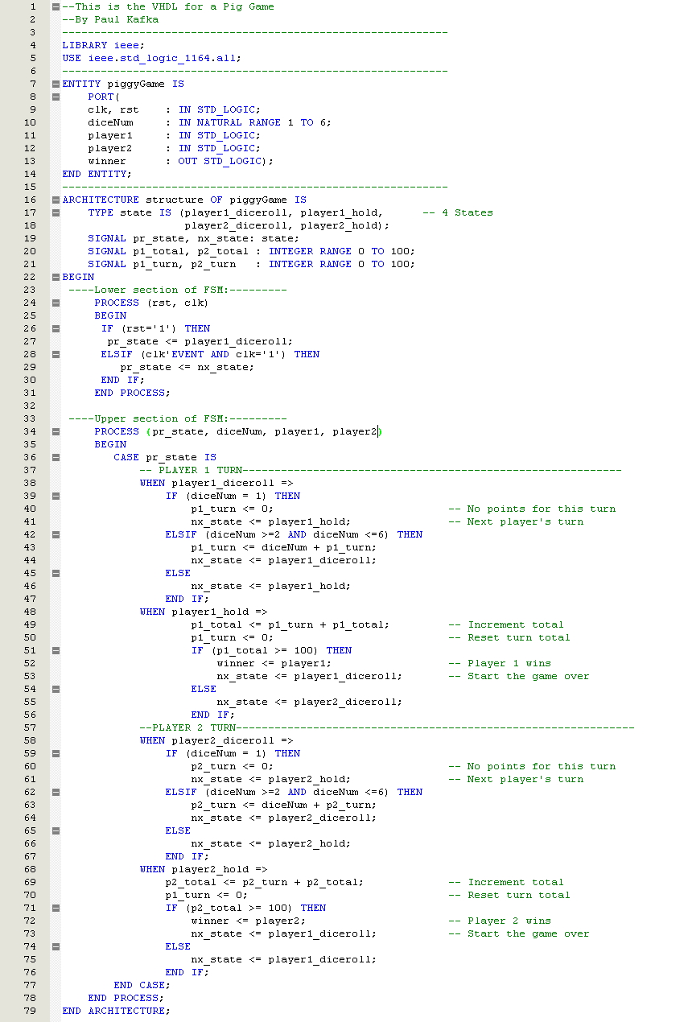
Pig Game Code

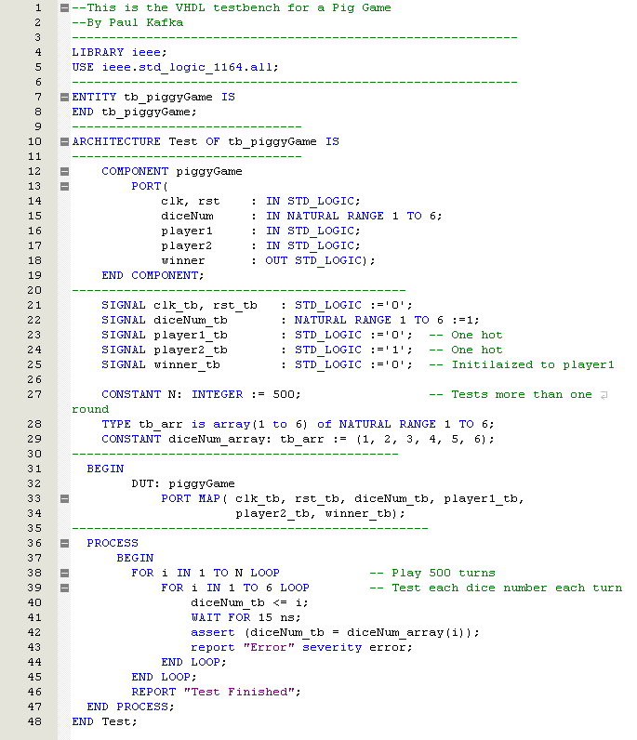
Test Bench Code
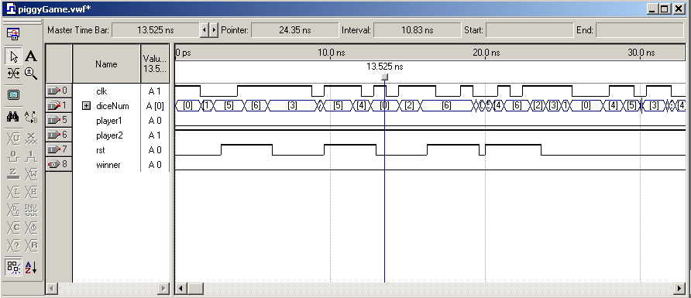
Waveform

